The CalSAWS conversion process requires that a Responsible Party record be identified as either an individual or an organization. VACS does not store this information so it will require a manual update to the data. A Debtor record that is determined to be an organization should have an “*” placed in the Debtor 1 Middle Initial field.
One way to identify potential organizations is to filter the Responsible Party extract screen to show only records that have an Organization ID. The Organization ID is the Provider Number from the VACS Debtor screen.
To filter the records, click on the Filter button and type this into the dialog box and click OK:
organizationid <> ""

Double-click on a record that is determined to be an organization. That will put the Legacy Account Number or Case Number into the windows clipboard. If the record has a numeric Legacy Account Number, then that will be placed in the clipboard since it represents a CalWIN Claim ID. If the Number begins with an “X”, then the Case Number will be placed in the clipboard since the Case is not in CalWIN and doesn’t have a Claim ID. The Case Number represents a VACS Serial Number.
Then paste the number into the Search By field of the VACS Inquire screen and click either Serial Search or Claim ID Search. Go to the Debtor screen and update it with the “*” in the Debtor 1 Middle Initial. You will not see any changes to the extract file until the next update is installed. I recommend updating as many records as possible before installing the next update since the Organization ID will be left blank on records that represent individuals so it will be more difficult to identify potential organizations. Multiple records that have the same Organization Name and Person Identifier will only need to be fixed for one record since all of the records represent a single Debtor. For example:
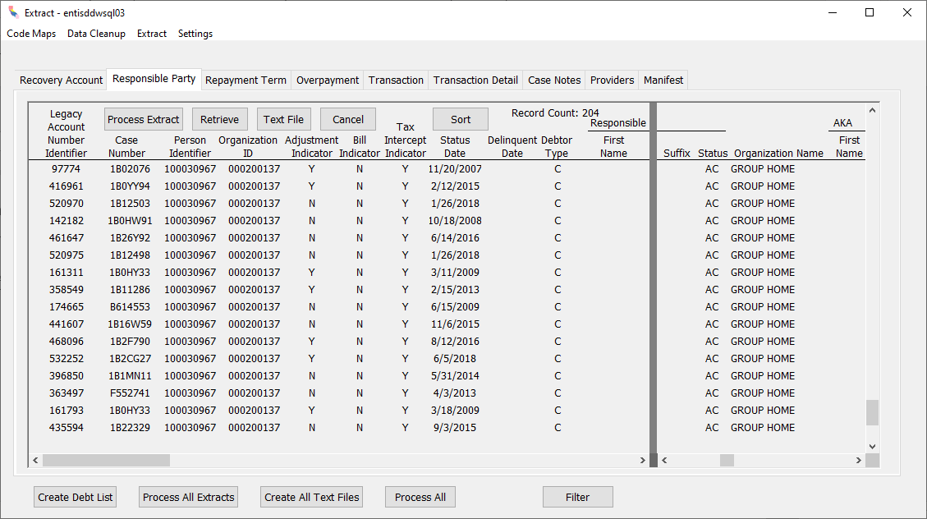
All of the records represent different Cases but the same Debtor. You can double-click on any of them and you will get the same Debtor record in VACS.

Here is another way of identifying potential organizations directly from the VACS database. This method will still work after the next upgrade is installed.
Run this query:
select debtor.debtor_id, debtor1_name_last, serial_number
from debt, debtor, DebtList
where debt.debtor_id = debtor.debtor_id and
debt.debt_number = DebtList.debt_number and
IsNull(provider_number, '') <> '' and
IsNull(debtor1_name_mid_init, '') <> '*'
order by debtor1_name_last

It will show debtor names and Serial Numbers of potential organizations that have not yet been updated. This can be useful to narrow down the result set as you update the Debtors.

